We now have access to automated captions inside our Zoom meetings – both live and recorded. While automated captions are a great resource for our students, they are not a replacement for professional captions. If you have a student in your course that requires captions as an accommodation, please work with the DSPS office to get professional captioning. The steps taken to enable the automated captions for both live and recorded meetings are below. For more detailed information on how automatic captions work, see Live Transcriptions for Meetings and Webinars on the TechConnect support site.

Enable transcription for recordings in your Zoom account. (Doing this once ensures all meetings you host and record include captions and an interactive transcript in the recording.)

- Go to https://miracosta-edu.zoom.us and sign in.
- Go into the Settings area, and to the Recording tab.
- Scroll down near the bottom, to the section labeled “Advanced cloud recording settings”.
- Check the box to enable “Audio transcript”.
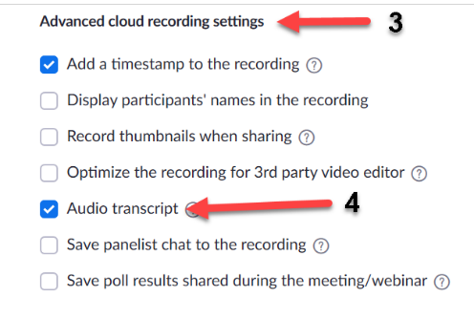
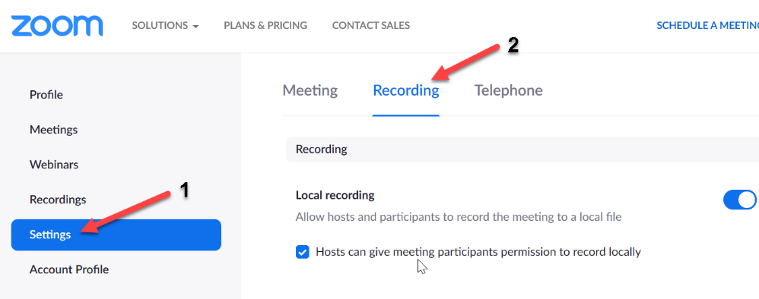

2. Start the Live Transcript during each Zoom session you host. (This is done every time you start a meeting to enable live captions and a transcript option.)
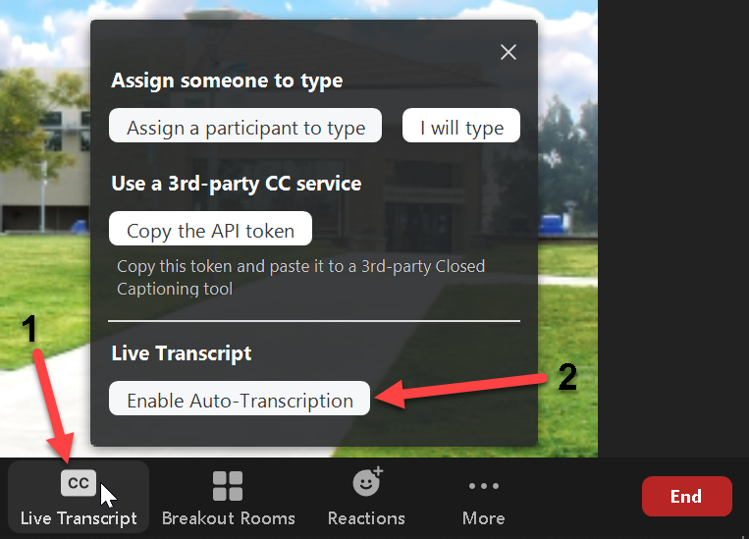
- Open the “Live Transcript” menu on your meeting toolbar. This will be either a button with “CC” icon, or an entry in the “More” menu, depending on how you have your meeting window arranged.
- In the “Live Transcript” section, click the button to “Enable Auto-Transcription”.

